Reflective Journal: Image Classification using Support Vector Machine (SVM)

# Reflection on Learning

## 1. Understanding the SVM Algorithm

What is SVM?  
Through this exercise, I deepened my understanding of Support Vector Machines (SVM). SVM is a supervised learning algorithm that seeks to find an optimal hyperplane that separates data points from different classes with the largest possible margin. In the case of image classification, this translates into classifying images into categories such as cars, animals, and planes, which was the focus of my lab.

Application in Image Classification  
The SVM algorithm was applied to a subset of the CIFAR-10 dataset, which contains 32x32 pixel images across 10 different classes. While typically SVM is better suited for smaller datasets and more structured data, this lab allowed me to experiment with it on image classification, which is more complex and high-dimensional.

## 2. Data Preparation Steps

Loading and Exploring the CIFAR-10 Dataset  
My first task was to load the CIFAR-10 dataset using TensorFlow. I then explored the dataset by visualizing some sample images. This step was crucial as it helped me understand the nature of the data I would be working with.

Grayscale Conversion and Flattening  
One of the key steps in preparing the data for the SVM model was converting the RGB images to grayscale, which reduced the complexity of the data. Since each image was initially represented by three color channels (Red, Green, Blue), reducing it to grayscale simplified the data by only having one channel. Then, I flattened the images, which transformed each 32x32 image into a 1D array of 1024 features.

Dataset Splitting  
After preprocessing the data, I split the dataset into training and testing sets. This ensured that the SVM model would be trained on one set of images and tested on an entirely different set, allowing me to evaluate the model's generalization performance effectively.

## 3. Model Training with SVM

Training Process  
Once the data was ready, I proceeded to train the SVM model using the `SVC()` function from Scikit-learn. The model was trained on the grayscale, flattened images. I chose a linear kernel as a starting point since it is faster and less computationally expensive compared to non-linear kernels such as RBF. However, this choice also has limitations when the data is not linearly separable.

Challenges  
One of the biggest challenges I faced during training was the computational intensity of SVM when working with image data. While SVM is effective for lower-dimensional data, image data with many features significantly increased the time it took to train the model. I also observed that the model struggled with certain classes that had high overlap in visual features, such as cats and dogs.

Overcoming the Challenge  
To mitigate the computational load, I worked with a smaller subset of the CIFAR-10 dataset. I also experimented with different kernel functions to see how they impacted the model's performance, ultimately sticking to the linear kernel for simplicity in this case.

## 4. Model Evaluation and Insights

Predictions and Accuracy

After training the Support Vector Machine (SVM) model on the CIFAR-10 dataset, I moved on to making predictions using the test set. This was the real test to see how well the model had learned to classify the different images. As I ran the model on the unseen data, I noticed that it performed reasonably well for certain classes, like airplanes and ships, which have distinctive features. However, the model struggled with more visually similar categories, particularly animals like cats and dogs. These images share subtle details, making it harder for the SVM to differentiate between them.

When I calculated the accuracy, I found that the model was able to correctly classify a significant portion of the images, but the accuracy wasn’t as high as I had hoped. This was somewhat expected given the complexity of image data and the limitations of SVMs when handling high-dimensional data. The confusion matrix provided additional insight by showing where the model had the most trouble. For example, it frequently confused dogs with cats and birds with airplanes, likely due to the grayscale conversion and loss of detailed color information.

Overall, while the accuracy was decent for some classes, it was clear that the SVM wasn't capturing all the nuances of the CIFAR-10 dataset. This experience highlighted for me that while SVMs can be effective, they aren't always the best choice for complex image data like this. I came away with a deeper understanding of the algorithm's strengths and limitations.

Insights  
A key insight from this project was the realization that SVM, although a powerful classifier for many tasks, has limitations when applied to complex image data. The model’s relatively low accuracy, especially when dealing with visually similar classes, highlighted that more sophisticated models like Convolutional Neural Networks (CNNs) would likely perform better due to their ability to capture spatial hierarchies in the data.

# Responses to Lab Questions

Why Convert Images to Grayscale?  
Converting images to grayscale reduced the dimensionality of the data while still retaining key features. Since SVM works better with 2D feature spaces, this step was crucial to simplify the input data while maintaining relevant information for classification.

What are Support Vectors?  
Support vectors are the key data points that lie closest to the decision boundary (hyperplane) in the SVM algorithm. They are critical because they define the margin and ultimately determine the optimal hyperplane that separates different classes.

How Does the Choice of Kernel Impact the Model?  
The kernel function determines how the data is transformed into a higher-dimensional space, making it easier to separate classes. A linear kernel assumes the data is linearly separable, while kernels like RBF or polynomial are more effective when classes are not linearly separable. Choosing the right kernel significantly affects the performance of the SVM.

# Inclusion of Visuals

Original and Grayscale Images:  
I visualized several images from the CIFAR-10 dataset in their original color format, grayscale, and after normalization. These visuals helped me understand how the preprocessing steps affected the data. Below are examples of the original and preprocessed images from the dataset:

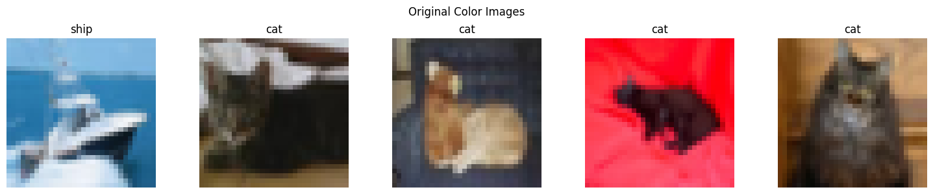

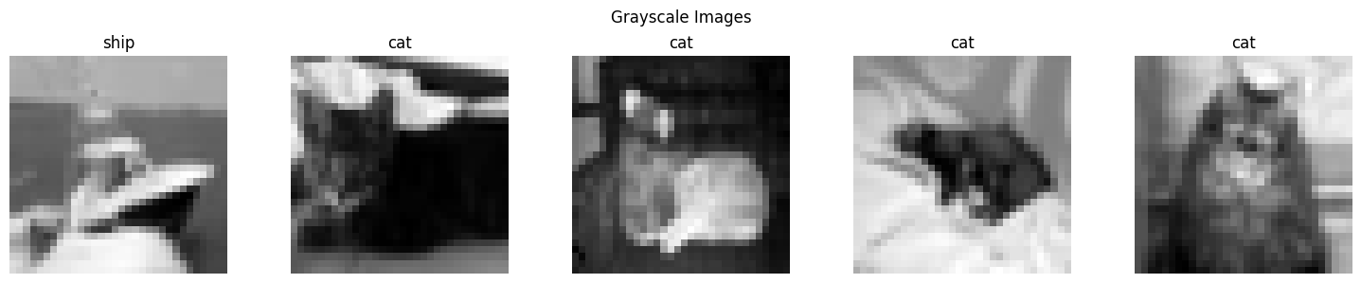

# Critical Analysis & Referencing

Critical Engagement with Results  
While SVM is a powerful classification algorithm, its application to image data is limited by the high dimensionality and visual complexity of images. The model achieved moderate accuracy but struggled with classes that had overlapping features, like cats and dogs. In future image classification tasks, models like CNNs, which can automatically learn spatial hierarchies and patterns, are likely to perform much better than SVM.

Applicability in Other Scenarios  
Despite the challenges I faced, SVM could still be a suitable choice for other types of classification tasks, such as in fields where the dataset is smaller or where features are more distinct (e.g., text classification or structured data).

# References

Pedregosa et al., "Scikit-learn: Machine Learning in Python," Journal of Machine Learning Research, 2011.  
Goodfellow, I., Bengio, Y., Courville, A., "Deep Learning," MIT Press, 2016.

**Bishop, C. M. (2006).** Pattern Recognition and Machine Learning. *Springer*.

**Cortes, C., & Vapnik, V. (1995).** Support-vector networks. *Machine Learning, 20*(3), 273-297.

**Krizhevsky, A., & Hinton, G. (2009).** Learning multiple layers of features from tiny images. *Technical Report, University of Toronto*